
KENBRIGHT ACTUARIAL AND FINANCIAL SERVICES LIMITED
DEPOSIT ADMINISTRATION & INDIVIDUAL PENSION PLANS VALUATION MANUAL
INTERNAL TECHNICAL PROCEDURES MANUAL
VERSION 1.0
JANUARY 2026
KAFS POLICY

Kenbright Actuarial & Financial Services Limited
26th Floor- Prism Towers – 3rd Ngong Avenue
P. O. Box 28281 – 00200
Nairobi, Kenya
kafs@kenbright.co.ke

 |  | 

DOCUMENT TRACKING
Revision History
Version | Author | Date | Revision
1.0 | Kenbright Actuarial and Financial Services Limited | January 2026 | Creation

Prepared for:

Kenbright Actuarial & Financial Services Limited
26th Floor, Prism Towers
3rd Ngong Avenue, Upperhill
P.O Box 28281 - 00200
Nairobi, Kenya

OUR REF
\\Kenbright\Internal Technical Procedures\ KAFS_Internal Technical Procedures_DA & IPP - Valuation Manual) _ (0126)

DOCUMENT PURPOSE
This document has been produced as part of the internal technical procedures for KAFS and provides guidance on DA & IPP Valuation.

DOCUMENT OWNERSHIP
The owner of this document is Kenbright Actuarial and Financial Services Limited.
TABLE OF CONTENTS
1 DEPOSIT ADMINISTRATION & INDIVIDUAL PENSION PLANS 4
Deposit Administration (DA) Schemes 4
Overview 4
Key Features: 4
Declared Returns 5
Individual Pension Plans (IPP) 6
Overview 6
Key Features: 6
Summary Comparison 6
Pension Business Market Summary 7
2 DATA REQUIREMENTS 8
Deposit Administration Policies 8
Summary Schedule (Policy Level Data) 8
Detailed Schedule (Member Level Data) 8
Individual Personal Pension Plan 9
Financial Statements & Solvency Report 9
Previous Valuation Reports 9
3 DATA CHECKS 10
Reasonability & Appropriateness Checks 10
Completeness & Accuracy Checks 11
Notes 11
Sign-Off 11
4 VALUATION 12
Fund Balance at Year End 12
5 DATA COLLECTION TEMPLATE 13
6 APPROVAL 15

DEPOSIT ADMINISTRATION & INDIVIDUAL PENSION PLANS
  - In the Kenyan pension industry, the two main types of pension arrangements are Deposit Administration (DA) and Individual Pension Plans (IPP).

Deposit Administration (DA) Schemes

Overview
  - A Deposit Administration Scheme is a group pension arrangement typically established by an employer for its employees.
  - The employer and employee make regular contributions, which are pooled into a single fund managed by an insurance company.
  - The insurer credits the scheme with annual interest (declared rate of return) based on the performance of the underlying investments.
  - The insurance company also charges a management fee, which is typically deducted from the fund’s investment returns to cover administrative, investment, and operational expenses associated with managing the scheme.

Key Features:
  - Some key features of Deposit Administration schemes include:
- Managed by an insurance company on behalf of a group of members (employees).
- Funds are held in a pooled account rather than in individual member accounts.
- The insurer declares an annual interest rate (bonus/crediting rate) to be applied to members’ balances.
- Withdrawals (e.g., retirements, resignations) are paid from the accumulated fund value.
- The employer bears no investment risk beyond its contribution obligations — the investment risk lies with the insurer.

Declared Returns
  - The table below shows the declared returns for the life insurance industry from FY2018 to FY2023.
Declared Bonus Rates (Interest Rates) Per Company
Insurer | FY2018 | FY2019 | FY2020 | FY2021 | FY2022 | FY2023
APA Life Insurance Ltd | 10.25% | 10.50% | 10.00% | 10.00% | 9.50% | 10.50%
Britam Life Assurance Co. (K) Ltd | 6.00% | 10.00% | 6.00% | 10.00% | 8.50% | 7.00%
CIC Life Assurance Ltd | 9.50% | 10.00% | 7.00% | 10.00% | 8.00% | 10.75%
Equity Life Assurance (K) Ltd | 0.00% | 0.00% | 0.00% | 0.00% | 0.00% | 10.50%
GA Insurance Ltd | 10.50% | 11.25% | 10.50% | 11.25% | 10.75% | 11.15%
Geminia Life Insurance Company Ltd | 0.00% | 8.00% | 8.00% | 9.50% | 8.00% | 8.00%
ICEA Lion Life Assurance Company Ltd | 9.00% | 10.25% | 8.00% | 9.25% | 6.50% | 10.00%
Jubilee Life Insurance Co. Kenya Ltd | 8.00% | 10.00% | 8.81% | 10.12% | 9.50% | 10.45%
Kenindia Assurance Company Ltd | 11.75% | 11.00% | 10.75% | 10.75% | 10.75% | 11.25%
Kenya Orient Life Assurance Ltd | 7.00% | 10.00% | 10.00% | 10.00% | 11.00% | 11.00%
Kenyan Alliance Insurance Company Ltd | 9.00% | 9.00% | 9.00% | 9.00% | 9.00% | 12.00%
Madison Life Insurance Kenya Ltd | 10.00% | 10.00% | 8.00% | 11.00% | 8.00% | 10.00%
Old Mutual Life Assurance Company Ltd | 6.00% | 9.00% | 6.00% | 6.00% | 7.00% | 2.00%
Pioneer Life Assurance Company Ltd | 11.50% | 11.00% | 9.00% | 10.25% | 10.00% | 10.50%
Prudential Assurance Kenya Ltd | 0.00% | 8.00% | 12.00% | 0.00% | 10.00% | 10.50%
Saham Insurance | 7.00% | 12.00% | 10.00% | 0.00% | 0.00% | 0.00%
Sanlam Life Insurance Ltd | 5.00% | 11.00% | 5.00% | 6.00% | 5.00% | 5.00%
The Monarch Insurance Company Ltd | 12.00% | 10.00% | 10.00% | 10.00% | 10.00% | 9.50%
Total | 8.83% | 9.94% | 8.46% | 9.54% | 8.84% | 9.01%
Source: AKI 2023 Report

Individual Pension Plans (IPP)
Overview
  - An Individual Pension Plan (also called Personal Pension Plan) is a retirement savings plan set up by an individual, usually not tied to an employer.
  - Contributions are made voluntarily by the individual and/or through a financial intermediary (e.g., insurance company or fund manager).

Key Features:
  - Key features of an IPP include:
- Designed for self-employed persons or employees whose employers do not operate occupational schemes.
- Each member has their own individual account — not pooled with others.
- Members can choose contribution levels and investment funds depending on the provider’s options.
- Benefits are portable (can move with the individual when they change jobs).
- Regulated under the Retirement Benefits Authority (RBA) framework.
  - Examples of Pension schemes in Kenya:
- Zimele Personal Pension Plan
- Liberty Life Individual Pension Plan
- ICEA Lion Personal Pension Plan
  - The fund balance at year end for Individual Pension Plan (IPP) business is determined in a similar manner to that of a Deposit Administration (DA) scheme, with the main difference being that in IPPs, the balance reflects the member’s individual account value at the Valuation Date.

Summary Comparison
Feature | Deposit Administration (DA) | Individual Pension Plan (IPP)
Nature | Group scheme (employer-sponsored) | Individual scheme (self-sponsored)
Membership | Employees of an organization | Individuals, self-employed, informal sector
Fund Structure | Pooled fund managed by insurer | Separate account per member
Investment Risk | Insurer bears investment risk | Member bears investment risk
Contribution Source | Employer (and possibly employee) | Individual
Portability | Limited to within employer scheme | Fully portable
Regulator | RBA (Kenya) | RBA (Kenya)

Pension Business Market Summary
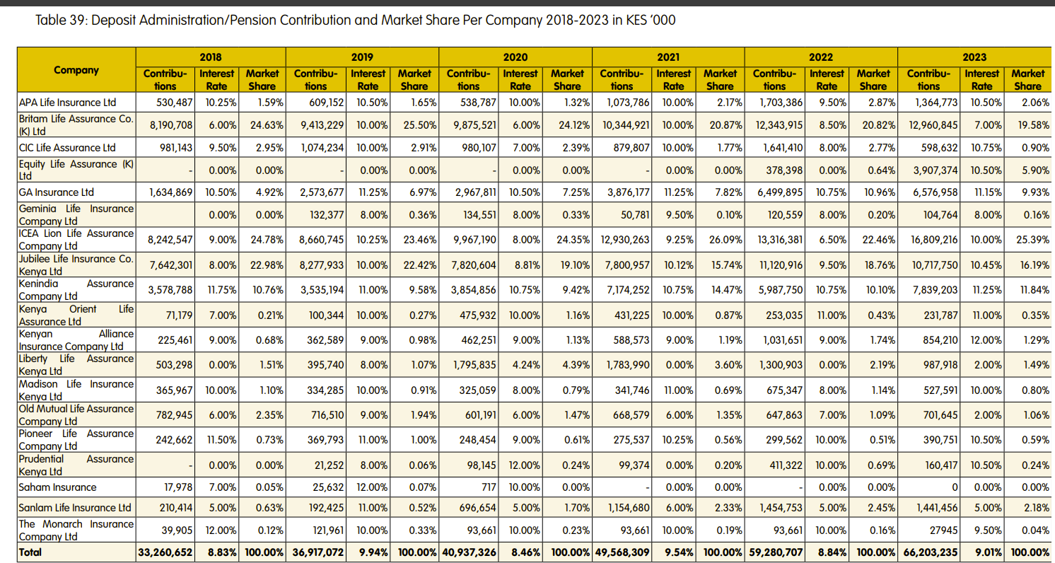
Source: AKI 2023 industry report

DATA REQUIREMENTS

  - The data required for the valuation of pension liabilities are:
- Detailed description of all pension products sold by the insurer;
- Contributions and withdrawals policy data for DA & IPP business for the year;
- Declared Interest Rate for the Year
- Financial Statements & Solvency Computations (at least 3 years);
- Previous Valuation Reports (at least 3 years).

Deposit Administration Policies

Summary Schedule (Policy Level Data)
  - This is a summary of the deposit administration policies in force as at the Valuation Date. The items required are as follows:
- Unique policy identifier – Policy Number(Scheme ID)
- Scheme commencement date
- Total number of members covered
- Total Opening Fund Value as at start of year
- Breakdown of total contributions over the inter-valuation period (as per contribution payment frequency)
- Breakdown of total transfers per policy into the Scheme over the inter-valuation period
- Breakdown of total withdrawals per policy over the inter-valuation period

Detailed Schedule (Member Level Data)
- Unique policy identifier – policy number
- Member number
- Member joining date
- Member Opening Fund Value as at start of year
- Breakdown of member contributions over the inter-valuation period (as per contribution payment frequency)
- Breakdown of member transfers into the Scheme over the inter-valuation period
- Breakdown of member withdrawals over the inter-valuation period

Individual Personal Pension Plan
  - The data required in these files are:
- Unique policy identifier – policy number
- Date of birth of assured life
- Issue date of the policy
- Opening Fund Value at start of year
- Contribution payment frequency – single, annual, semi-annually, quarterly or monthly etc
- Breakdown of total contributions over the inter-valuation period (as per contribution payment frequency)
- Breakdown of withdrawal amounts over the inter-valuation period
- Loan amount for Policy Loans, where applicable

Financial Statements & Solvency Report
  - The financial statements required for the valuation of life insurance technical liabilities are:
- Audited accounts for at least previous 3 years.
- Management accounts for the period to the Valuation Date

Previous Valuation Reports
  - Annual Actuarial Valuation Reports for the past 3 years will be required.
  - These will be used to assess actual emerging experience against assumptions used at previous valuation

DATA CHECKS

  - Upon receiving data, the next phase is carrying out data checks before the data is used in computations.
  - The aim is to review the credibility of the data provided which should include considerations of the data’s:
- Reasonability & Appropriateness
- Consistency; and
- Completeness & Accuracy

Reasonability & Appropriateness Checks
  - The following checks should be conducted:
          - Ensure that we have received full data as requested
          - Check each file to confirm that the data items requested are provided
          - Confirm that entries are saved in their right formats e.g. dates, numbers, and text
          - Identify unusual entries in the data that don’t make sense. These include blanks and unreasonable values such as negative, very small or zero values, and unusual dates
          - Check that the age of each member, at entry, meets the entry age requirement
  - Check that all entries have unique identifiers (e.g. policy and claim numbers) and that there are no duplicates
  - Perform random spot checks and any other checks to confirm the entries, make sense e.g. transaction dates are before the valuation dates etc.

Completeness & Accuracy Checks
  - Confirm the accuracy of the total amounts (e.g. Contributions and withdrawals) in the data shared by comparing them with the values disclosed in the accounts. Do this for all policy data files per scheme underwritten by the insurance company.

Notes
  - This manual is intended as a guide on the minimum considerations when performing checks on information and data received for a life insurance valuation exercise.
  - It is not intended to be an exhaustive guide of all requirements. Each client data set should be treated with keen consideration of their unique requirements.
  - Summarize all data received and any queries in a separate file to be sent to the client for clarification. Discuss the main issues with the Actuarial Manager before seeking clarification from the client.
  - Follow up on the queries raised to ensure that the data cleaning phase doesn’t affect the project timeline

Sign-Off
  - Highlight the need for assumptions to be made on the data and information provided, where necessary, and discuss this with the Actuarial Manager before sign-off.

VALUATION

Fund Balance at Year End

  - For DA & IPP business, the liability comprises of accumulation of the contributions and transfers made into the Fund, plus interest earned on the same at the declared interest rate.
  - For both Deposit Administration (DA) and Individual Pension Plan (IPP) business, the liability represents the accumulated value of all contributions and transfers made into the fund, together with the interest earned thereon, calculated using the declared annual interest rate over the valuation period
  - The fund balance for a DA & IPP Scheme at the end of the year can be determined as:
$$Fund Balance End of Year​=Opening Balance+Contributions Received-Withdrawals/Benefits Paid-Management Fees+Interest Credited$$
Component | Description
Opening Balance | Fund value at the start of the financial year.
Contributions Received | Employer and employee contributions made during the year.
Withdrawals/Benefits Paid | Amounts paid out to members who retire, resign, or withdraw.
Management Fees | Deduction made by the insurer for managing the fund (usually a % of the fund value).
Interest Credited | Annual declared rate of return applied to the fund balance after fees.

DATA COLLECTION TEMPLATE

Deposit Administration Valuation
General Information
 | Insurer:
 | Valuation Date:
Requested Data
1 | Audited Financial Statements for the past 3 years
2 | Management Accounts as at Valuation Date
3 | Detailed description of all DA & IPP products sold by the insurer
4 | Previous Actuarial Valuation Reports (past 3 years)
5 | Policy Level Data
 | a) Withdrawals data
 | b) Contribution Data

Policy Level Information
Life Business
Deposit Administration Policies
Summary Schedule (Policy Level Data)
Unique policy identifier - policy number
Commencement date
Total number of members covered
Total Opening Fund Value as at start of year
Breakdown of total contributions over the inter-valuation period
Breakdown of total monthly transfers into the Scheme over the inter-valuation period
Breakdown of total monthly withdrawals over the inter valuation period
Detailed Schedule (Member Level Data)
Unique policy identifier - policy number
Member number
Gender
Date of birth of member
Member joining date
Member Opening Fund Value as at start of year
Breakdown of member contributions over the inter-valuation period
Breakdown of member monthly transfers into the Scheme over the inter-valuation period
Breakdown of member monthly withdrawals over the inter-valuation period

Sign-Off Template
Sign-off
Statement by the Lead Analyst
I have acquired the required data from the client and did data validation in line with the KAFS Internal Technical Procedure on Data & Checks. The key assumptions made are summarized below:
Key Assumptions
1
2
3
4
5
Name:
Date:
Statement by the Supervisor
I have reviewed the data validation process and discussed the issues encountered and the key assumptions made by the Lead Analyst. I confirm that the data is appropriate for use.
Name:
Date:

APPROVAL

Thus, adopted and signed by the management and Chief Actuary of KAFS in January 2026.
APPROVED BY
Ezekiel Macharia
Chief Actuary & Managing Director – Kenbright Actuarial and Financial Services Limited

Date: January 2026
Signed:



About Us

Kenbright Actuarial & Financial Services Limited (KAFS)
Prism Towers, 26th Floor
3rd Ngong Avenue, Nairobi
Kenya
www.kenbright.co.ke

Customer Service Lines: +254 (020) 22 111 52

Document Version

January 2026

Version 1.0: Creation

Reproduction – in total or in part – only with the permission of KAFS.

Key Contacts

E Macharia, FIA C.Act, FeASK
Chief Actuary & Managing Director
E-mail: ezekiel@kenbright.africa
Phone: +254 722 540 045

